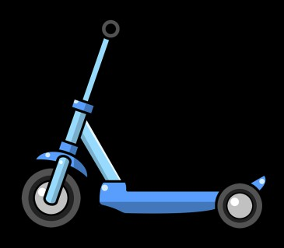

**Grade 3-English**

**Name:________________ Date:_______**

MY NEW SCOOTER

It was amazing. I couldn’t keep my eyes off of it. The way it shined in the light kept drawing my eye back to it. My dad noticed.

“Sophie, you have a scooter already, a really nice   
one!”

“I know, but look at this one! It’s so shiny and new,” I said.   
“It is great, but we have to get going. Come on,” said Dad.

We left the store, with me taking one last glance back at the new scooter. I   
knew my scooter was nice, and it still worked even though I’d gotten it for   
my birthday 3 years ago. I just couldn’t stop thinking of that new scooter!

A few weeks later, Dad and I were back in the store. The scooter wasn’t on display where it was before, but as we passed the toy section, I kept my eyes open for it. There it was, with a big sale sign on it! I couldn’t help   
myself, I ran right over to it. Dad looked at the price.

“I know you’ve been thinking about this scooter a lot, Sophie, and you

haven’t asked for much from me or Mom lately. You’ve been helpful around   
the house, too. The sale price is pretty good, though it’s still a lot of money.   
I can’t just buy this for you, but what if I pay for part of it, then lend you the   
money for the rest of the scooter, and you promise to pay me back?” Dad   
asked.

“Would you really?” I said excitedly. “I promise I will pay you back, I will!”

“Sure, let’s get it,” said Dad as he picked up the box. As we were walking   
toward the registers, Dad asked me if I knew what it meant to borrow   
money.

“Yes, it means that I have to give it back to you,” I answered.

Dad responded, “You’re right, but you can give it back to me a little at a time. Right now you get five dollars a week for your allowance. Instead of using it for a little treat, you could pay it back to me until you pay off your part of the scooter. It will take a couple of months for you to be done paying me back for it if you do that. Does that work for you?”

“Sure, Dad! Thank you so much, I can’t wait to use my new scooter! I will pay you back with my allowance until I return all the money I’m borrowing from you today. You’re the best!”

Answer each question:

1. How do you think Sophie will feel when she gives her dad her allowance   
    each week? Why?
2. Sophie borrowed money for her new scooter. When are other times   
    people might borrow money?
3. What does glance mean in the 5th paragraph? How do you know?
4. What do you think Sophie will do with her old scooter? Why?